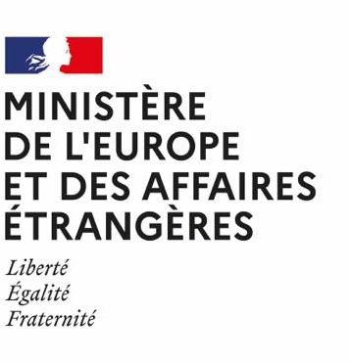
Candidate photo photo

Sound Documentary Intensive Summer Program
École nationale supérieure Louis-Lumière
with the support of the
French Ministry for Europe and Foreign Affairs

July 13th – August 28th 2026 (dates TBC)

APPLICATION FILE

PERSONAL INFORMATION:
Surname:
First name:
Nationality:
Permanent Address:
Country/Region:
Street:
City:

State:

Postal Code:

Personal situation:
- Student
Name of the School / Department / Major:
Year of study:

 Young professional Function: Company:
Field of activity:
Other:
Date of birth:
Age:
Cell phone number:
E-mail:

Diploma:

Year | Diploma / Name of the  school/university | Grade | Description

Other:

Year | Name of the school | Description | Duration

Professional experience:

Year | Name of the entity | Description (function)

YOUR INTEREST IN THIS WORKSHOP
Please answer the following questions precisely.
Please note that these elements are meant to help the jury assess your familiarity with sound practices. However, this program will not be dedicated to carrying out personal projects.

- Do you listen to radio documentaries? If so, please specify where – radios, web radios, podcasts, festivals, etc.

- Have you already produced a radio / podcast work, or a creative work involving sound? Or any kind of audiovisual work?
If so, please submit link.
If not in English or French, all the works must be accompanied by a synopsis in English in order to be taken into consideration.

- Do you currently have a radio / podcast project, or a creative project involving sound? If so, please provide a 1-page synopsis.

- In your opinion, what impact will your stay in France have on your professional career?

- How do you imagine your career in 5 years? Be as precise as possible.

YOUR SKILLS

English : Poor  / Fair  / Good  / Excellent

Have you ever been to France? If so, why and for how long? Tourism, linguistic stay, studies?

Sound recording skills (specify equipment)

Equipment:
Level | Poor | Fair | Good | Excellent

Use of sound editing software (specify software)

Software:
Level | Poor | Fair

Good | Excellent

Documents to be attached to this application:

- CV (1 page) (in English)
- A cover letter (in English) explaining the various reasons why you are applying for this Program (1 page)
- A 1-page synopsis of your current sound-based project
- An English transcript of at least the first ten minutes of the podcast submitted.
- An ID photo in digital format, to be inserted at the top of the initial page of this file.

IMPORTANT :
All documents including this form must be gathered in one PDF
All submitted links must be accessible without subscription and active

