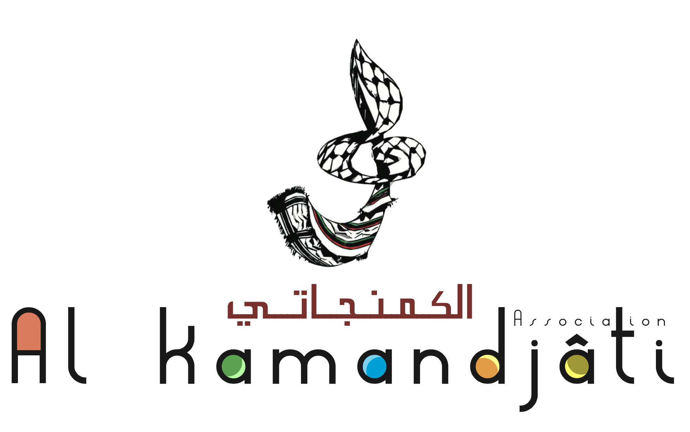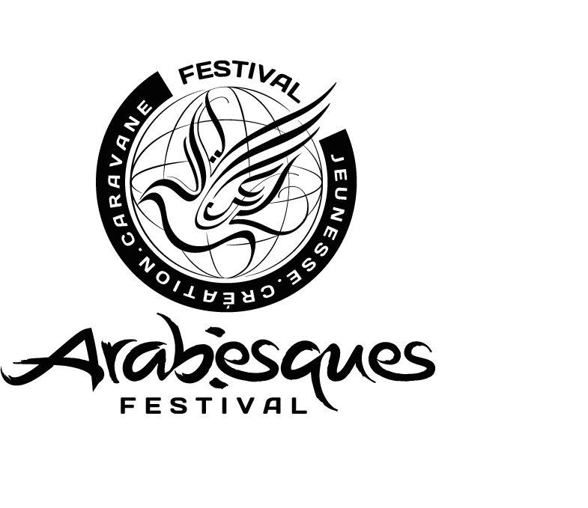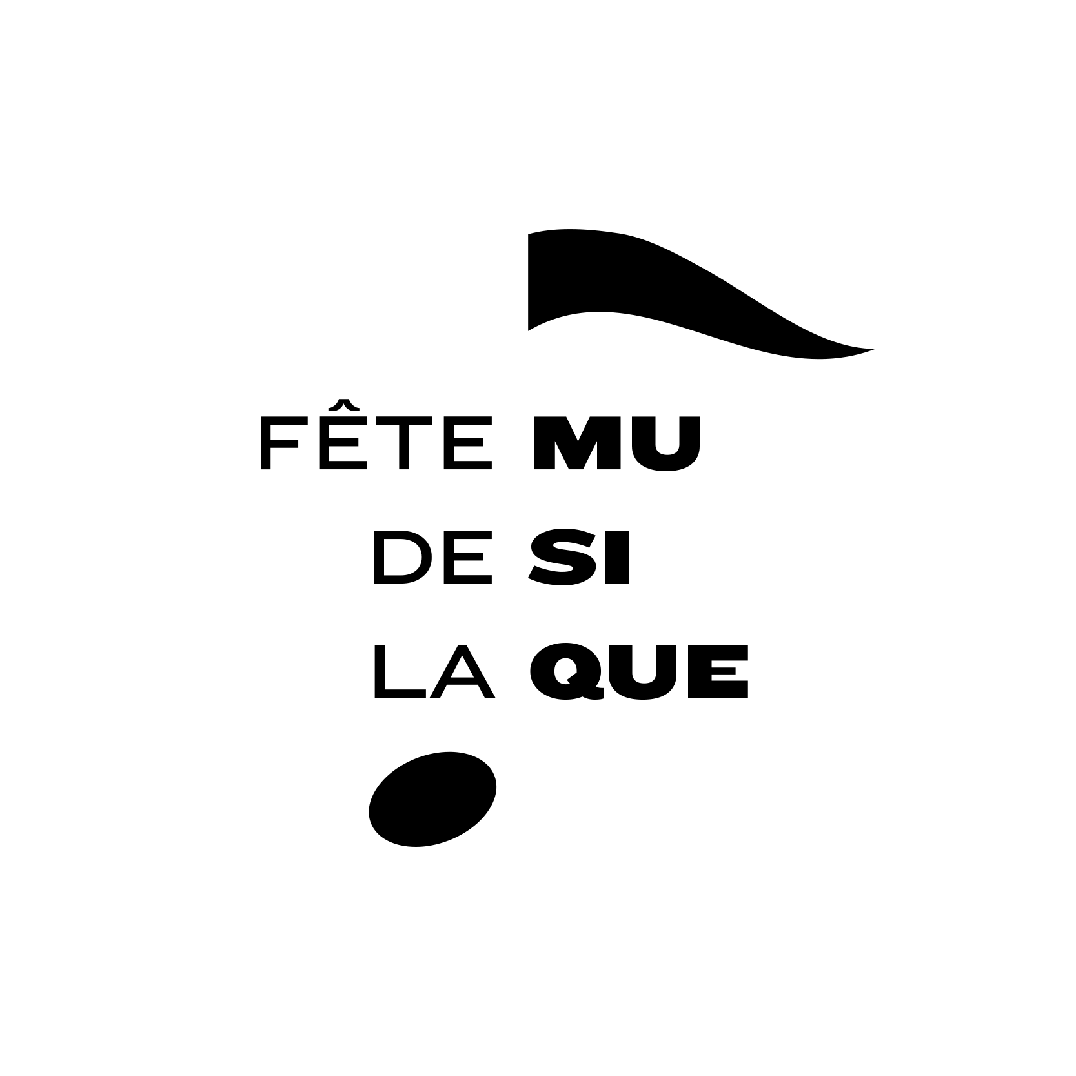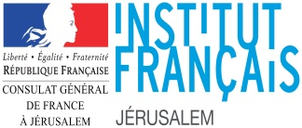

Fête de la musique - Application Form

Description

In France the Fête de la Musique has been held every year since 1981 and has become a popular event. For several years now, the French Institute of Jerusalem has organised concerts for the Palestinian public on this occasion.

Although it is impossible to schedule the concert tour in the West Bank, it would be regrettable not to maintain an event for this important date in the cultural agenda. This is why we have chosen to use social networks and organise the 1st 100% online music festival in Palestine. The event will take the format of an online competition open to Palestinian music groups.

This online music competition will also be an opportunity to promote and help the development of musicians in Palestine.

Eligibility criteria

* The application is valid for individuals and groups (within the limit of 4 musicians per band)
* The applicants must be over 18 years old (ID attached to the application), Palestinians, living whether in Gaza, West Bank or Jerusalem.
* The organisers maintains the right to not approve any application not submitted within the timeframe or not meeting the criteria
* The lyrics of the songs can be in any language (English, arabic, french, ...)
* The email should contain the following subject : “FDLM 2020 + name of applicant”
* Applications must be submitted before June 5th
* In order to be eligible, your application must contain :
  + 2 tracks recorded in video (max. 8 min. in total)
  + A short description of your group (style, origin, etc.)

How to apply

* The application should be filled in English and emailed to : music[@consulfrance-jerusalem.org](mailto:music@consulfrance-jerusalem.org)
* The email should contain the following subject : “FDLM 2020 + name of applicant”
* The videos should not be attached in the email, the application shall contain a WeTransfer link
* Videos must be filmed in landscape format and must be sent in high-resolution quality

Voting system

* The jury will meet to select the 10 musicians or bands who will participate in the Online Music Competition.
* Videos of the 10 contestants will be published on our social media on 21st of June. The audience will be invited to vote online on the next day (22nd of June) via a poll in order to determine the winners.
* The applicant will be selected based on :
  + Stage presence
  + Harmony of the music
  + Rhythmic
  + Originality of the video
  + Quality of the recording process
  + Quality of the performance

Prizes for contest winners

* 1st place: 10 000 NIS + 1 artistic residency in France (1 week) + booking at the Arabesques Festival 2021 + artistic coaching by Al Kamandjati
* 2nd place: 5,000 NIS + Concert in West Bank + Al Kamandjati artistic coaching

Legal notice

The work will stay the property of the artist but will be used by the French Institute and the partners during the project and may be re-used for non-commercial purposes with the prior information of the artists.

The online music contest is a project proposed by the French institute in Jerusalem, in partnership with Al Kamandjati and Arabesques Festival (France).

Videos sent must not contravene the instructions of the official authorities.

|  |  |
| --- | --- |
| **General information** | |
| Name of the applicant or band |  |
| Number of musicians |  |
| Contact person |  |
| Nationality |  |
| Date of birth |  |
| Adress |  |
| Email address |  |
| Phone number |  |
| Website and/or social media |  |

|  |  |
| --- | --- |
| **Artwork** | |
| Short description of your band |  |
| Title of the songs |  |
| Genre of the songs |  |
| Short statement of the ideas you want to express in your songs |  |
| Link of the WeTransfer for the videos |  |

I hereby certify that the above information are true and accurate to the best of my knowledge.

Date :

Signature :